PRESS RELEASE

THE “URBIS” EXHIBITION PRESENTS 150 WORKS BY THE ARTIST GASPARE MANOS UNDER THE PATRONAGE OF THE REGION, PROVINCE AND CITY OF VENICE OPENS AT THE DIOCESANO MUSEUM IN VENICE. 1-28 SEPTEMBER 2008 DURING THE 11th VENICE BIENNALE OF ARCHITECTURE.

THE CATALOGUE CONTAINS IMPORTANT TEXTS BY ROSA MARIA MALET IN BARCELONA, AND BY ALAN JONES, THE NEW YORK WRITER AND ONE OF THE MOST IMPORTANT ART HISTORIANS OF OUR TIME.

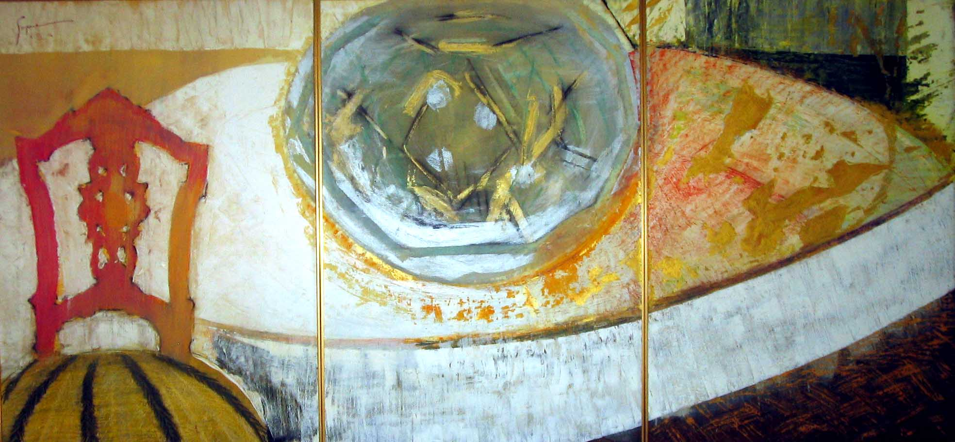
The Besarel Tryptich 210 cm x 70 cm - 2006 - gaspare-foundation Collection

The exhibition called “URBIS” at the Diocesano Museum in Venice is timed to coincide with the 11th International Biennale of Architecture and is officially inaugurated on Saturday 13th September 2008. In over 150 paintings and drawings from the period 1982-2007 the artist aims at bridging the widening gap- almost a divorce- that has developed between painting and architecture in modern times. The architect, by imposing his total vision through buildings, spaces and even furnishings, has pushed out any other form of expression that may detract from his own, leaving the patron/collector often feeling like a guest in his own house.
The artist reaffirms the right of the painter to offer his own vision – complementary but autonomous – and recognizes to the patron/collector the pleasure and the responsibility to construct and live in a world that is his own.
The 11th Venice Biennale of Architecture offers an ideal opportunity for such a reappraisal, especially in view of the objectives that its curator, Aaron Betsky has described as “an exhibition that wants to orient itself towards an architecture freed from buildings, in order to face the central themes of our society, that may help us understand and give meaning to our modern world and make us feel at home in it.”

GASPARE explores, through the theme of the city and a distinct painting technique, the subtle divide between figurative and abstract representation: a research lasting him over 25 years to define the universe that divides ‘reality’ from ‘memory’. His work shows an extraordinary imagination that led the philosopher Karl Popper to define this artist as the ‘immaginifico of contemporary art’.

The visitors to the URBIS exhibition will be able to admire the Museo Diocesano and its Cloister of Sant’Apollonia, an architectural jewel dating back to the XII Century, only
a few steps from Piazza San Marco and the Bridge of Sighs (Ponte dei Sospiri).

BIOGRAPHY:

GASPARE is considered one of the most significant European artists of his generation. Italian, of Venetian and Dalmatian origins, born in Bangkok/Thailand in 1968, GASPARE is resident in London. He has lived in Nairobi, Geneva, Athens, Paris, Brussels and to over 100 countries. His works are present in numerous collections. Encouraged to paint by giants such as Lucian Freud and others, the works of this artist have been admired by some of the great minds of our time, from the philosopher Karl Popper to the Nobel Prize Saul Bellow. See www.gaspare-foundation.com for more information.
During the second half of 2008, two more exhibitions of works by the artist are planned in Vienna (at MEL CONTEMPORARY) and New York. The artist currently works alternating between the UK, Venice and Barcelona.

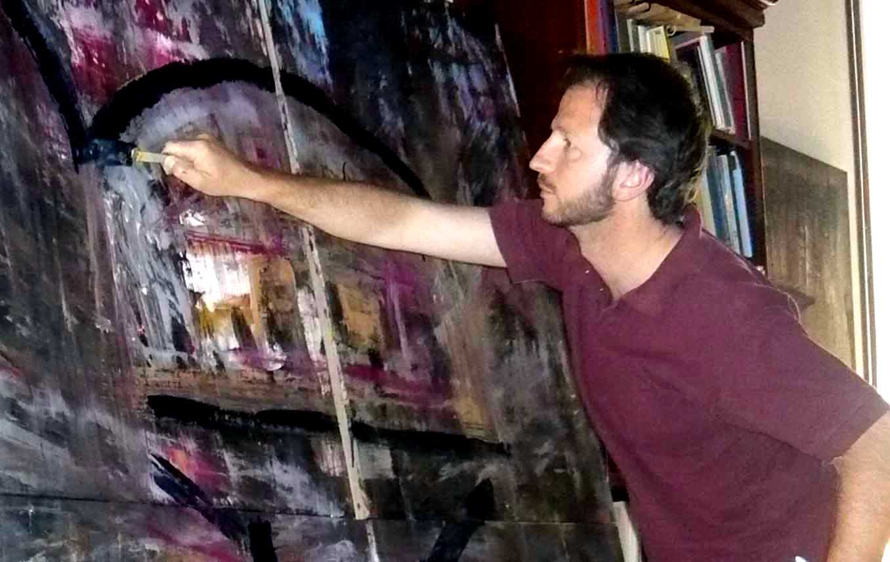
Foto of GASPARE painting. (c) Archive www.gaspare-foundation.com

Museo Dicesano per informazioni e catalogo
Castello, 4312, Ponte della Canonica, Venezia, 30124
Tel: 0415229166 Fax 0412702420 for further info:email info@gaspare-foundation.com
